Technical Development Program   
SPREAD 2016

May 2016

Morocco

Kiln Optimization  
  
Case Study

Version 2016  
  
LafargeHolcim Ltd.  
Cement Industrial Performance

Introduction

You are the Process Performance Engineer in the clinker production department of the 'Dandelion' cement plant.

The 'Dandelion' plant is located 450 m above sea level. The plant, commissioned in 1974, includes one ball mill for raw meal preparation, one dry suspension preheater kiln (Polysius DOPOL, original design capacity 1’500 t/d) with grate cooler and two ball mills for cement grinding.

Several **upgrades** have been made in the past years:

* High momentum kiln burner
* Pfister kiln feed dosing system
* Dip tubes in all cyclone stages
* Fixed cooler inlet (KIDS)
* Precalciner with tertiary air duct designed for 2'500 t/d production
* Installation of retractable kiln inlet probe
* New dynamic separator for the coal mill

However, after the installation of the new precalciner early this year (Jan/Feb), the new design capacity (2'500 t/d) kiln could not be reached. Further the kiln system availability is too low (mainly due to ID-fan failures, refractory failure at the kiln outlet and kiln drive failures).

The highest achieved clinker production is reported at **2'350 t/d**. The next annual kiln shutdown is scheduled in January next year.

Raw material and raw meal preparation

The raw material from the quarry is quite **uniform** in chemistry. The raw mill has a capacity of 230 t/h and can be operated mainly at low electricity tariff only (nighttime and weekends). A new Pfister kiln feed dosing system has been installed and no problems with kiln feed variations exist.

Fuels and AFR

**Imported coal** is used in the main burner as well as in the precalciner. The cost of coal is high and is expected to increase further. The use of AFR is in an initial phase, recently first AFR trials have been carried out.

Fuels and AFR

The coal mill is **not a bottleneck**. A recent coal mill audit concluded that the capacity is sufficient even if 100% petcoke substitution would be achieved in the future.

Quality

Clinker **free lime is within target**. Reduced early strength, which occasionally seemed to be a problem in the past, has improved considerably since the installation of the fixed inlet (KIDS).

Market

Due to the considerable growth of the GDP (Gross Domestic Product) in the country the market conditions for cement are **very promising** and every ton of additionally produced clinker could be sold.

Plant Equipment Data

* Rotary kiln (commissioned in 1974)   
  Original design capacity **1'500 t/d** (DOPOL without precalciner)  
  Shell dimension dia **4.7 m x 72 m, 3 piers,** inclination **3 % (or 1.72°)**  
  Refractory lining thickness: **20 cm**
* Kiln drive (girth and pinion)  
  **350 kW**, **2.2 rpm max**
* Preheater
  + **DOPOL** type **four stages**   
    No. of cyclones from top to bottom: 2, 2, 1, 2
  + All cyclone stages are equipped with **dip tubes.**Dip tube dimensions (stage 4 = top stage, stage 1 = bottom stage):
    - **Stage 4 (top):** dia = 2.2 m, length = 2.5 m
    - **Stage 3:** dia = 2.5 m, length = 1.5 m
    - **Stage 2:** dia = 3.3 m, length = 1.5 m
    - **Stage 1 (bottom):** dia = 1.9 m, length = 1.0 m
  + Narrowest **kiln inlet** section area **7.45 m2** (inside refractory,   
    measured at narrowest position limited by the inclined inlet chute)
* Precalciner
  + Inline calciner (vessel type)
  + Calciner volume: **440 m3** (inside refractory)
  + Tertiary air duct diameter: **1.7 m** (inside refractory)  
    Take-off from kiln hood
  + One meal feeding point to calciner
  + Burners: simple tube (without primary air and swirlers)
* Kiln hood net cross section **4.6 x 3.7 m** (inside refractory,   
  measured at cooler roof level)
* Clinker grate cooler
  + Fixed inlet with one high pressure variable speed   
    **fan #1**: 30'000 Nm3/h, max. 100 mbar
  + 2 grate sections each with a mechanical grate drive
  + Three cooling air fans with dampers for aeration of moving grates:
    - **Fan #2** for first grate, first compartment:   
      30'000 Nm3/h, max. 80 mbar
    - **Fan #3** for first grate, second compartment:   
      40'000 Nm3/h, max. 60 mbar
    - **Fan #4** for second grate, two compartments, air distribution by flaps:   
      90'000 Nm3/h, max. 20 mbar
  + Grate dimensions:
    - Fixed inlet: **3.1 x 2.6 m** (active area inside horseshoe: **7.44 m2**)
    - First grate: **3.1 x 9.3 m**
    - Second grate**: 3.1 x 11.8 m**
    - Total active cooling area: **72.85 m2**
* High momentum burner for coal (**9 N/MW**)
* Damper controlled kiln ID fan:
  + Speed: **990 rpm**
  + Design flow: **105 m3/s**
  + Design pressure: **60 mbar**
  + Motor power installed: **800 kW**
* Position of analyzers for kiln control
  + At kiln inlet
  + At preheater exit

Production Period Year 1

During the major shutdown in January / February a precalciner and tertiary air duct for a design capacity of 2'500 t/d was installed. After this upgrade the kiln BDP was increased to the project design capacity (2'500 t/d).

However up to now (June) this production rate could not be reached. Further several problems have arisen in the preheater and with the ID fan. Due to these problems and kiln failures (see also kiln downtime Pareto below) the budget clinker production volume (775'000 t/a) will by far not be reached and the market demand cannot be met. At the increased production rate, more frequent failures of the kiln drive occurred when operating above 1.8 rpm hence the upper speed limit of the kiln had to be set to 1.8 rpm.

The kiln ID fan with drive (still the original installation) provokes a lot of operation problems (high vibrations, motor temperature, bearing replacements) and is operated at the limit.

Further the kiln feed to clinker factor from last year (1.70) is still used. However, since the start up with the precalciner, a growing deviation from reported and measured clinker stock volume could be observed.

The main fuel for the kiln is imported coal, alternative fuels are still in trial phase. Recently the plant started also with first petcoke burning tests.

Some important kiln KPI in this year up to now:



Just recently a heat balance at full production was performed (see diagram below). The production determined with a clinker drop test was 2'350 t/d. The dust loss of the preheater was determined by a filter dust weigh out during raw mill stop (97.9 t of dust during 3 hours). During the heat balance the kiln was operated with coal as the only fuel (no alternative fuels).



**Lab Analysis Data during Heat Balance**



**Kiln Downtime Pareto Diagram for Year 1  
(Last 52 Weeks)**

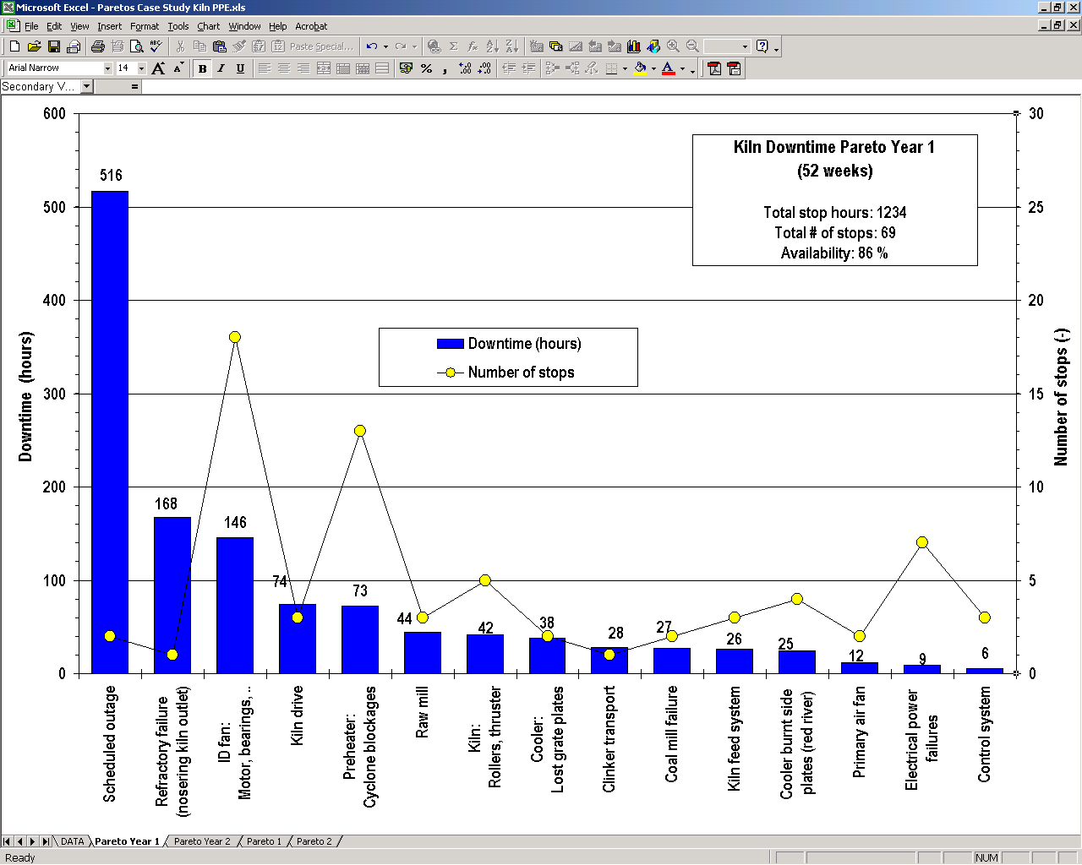

Your Tasks for the Year 1

The budget clinker production volume for the next year is identical to the current volume (775'000 t/a). However the long term market demand for cement in the country is growing and higher clinker production volumes are planned for the following years. The specific production costs (especially fuel costs) have to be reduced.

As the kiln performance is not satisfactory, you as the process performance engineer are now in charge of proposing the adequate measures to achieve the  
**targets for the next year:**

* **Clinker production of 775'000 t/a**
* **Kiln availability of 90%**
* **Reduction of specific thermal energy consumption by 5 %**

Question: What OEE and rate index in the next year is required to achieve your production target. Please insert your results in table below:

|  |  |  |
| --- | --- | --- |
| **Parameter** | **Unit** | **Value** |
| Required OEE to reach budget clinker production for next year (at current BDP of 2'500 t/d) | % |  |
| Required rate index if the Holcim target kiln availability of 90% is reached | % |  |

First you will **analyse the situation** (identify process problems related to equipment) and search for bottlenecks and weak points in the process that are limiting production.

Calculate and assess the following process parameters and process analysis indicators:  
  
**Important: Use the actual values measured during the heat balance of year 1**

| **Parameter** | **Unit** | **Value** | **Assessment, problems expected ?** |
| --- | --- | --- | --- |
| Burning zone area load of kiln | t/d m2 |  |  |
| Kiln volume load | t/d m3 |  |  |
| Split of heat input to kiln / precalciner | % / % | / |  |
| Thermal burning zone load of kiln | MW/m2 |  |  |
| Clinker cooler grate area load | t/d m2 |  |  |
| Specific cooling air volume at kiln outlet nose ring | m3/m s |  |  |
| Kiln feed / clinker factor  *(1.70 is existing factor used by prod. dept.)* | - |  |  |
| Separation efficiency of top cyclones (referred to kiln feed) | % |  |  |
| Gas velocity in dip tubes of bottom stage cyclones | m/s |  |  |
| Apparent calcination degree of hotmeal | % |  |  |
| Gas velocity in kiln inlet chamber *(Practical hint: assume the true and apparent calcination degree identical)* | m/s |  |  |
| Material residence time in kiln *(Hint: use 37° angle of repose of material)* | min |  |  |
| Material filling degree in kiln | % |  |  |
| Required kiln speed to reach a material residence time of 30 min | rpm |  |  |
| Required kiln drive power for an installed max. kiln speed of 4.5 rpm | kW |  |  |

Then the plant manager asks you to **locate the bottlenecks/weak points** that are currently limiting the clinker production volume. Name at least four weak points and indicate the impact on the process (e.g. clinker production volume, thermal energy consumption). Use information from the heat balance, Pareto, system loads and velocities and the calculations from the above table.

**Production Year 1**

|  |  |  |
| --- | --- | --- |
| **Process Analysis Indicator, Critical Process Parameter** | **Bottleneck,  Weak Point** | **Impact on Process  (e.g. production, heat consumption, cost)** |
|  |  |  |
|  |  |  |
|  |  |  |
|  |  |  |
|  |  |  |

Based on the analysis done above you **propose relevant improvement measures** that will allow you to reach the targets for the next year. Possible measures could be: change of kiln operation, modification or replacement of equipment, maintenance. Also estimate the expected CAPEX and kiln downtime in case of equipment modifications.

**Year 1: Improvement Measure # 1**

|  |  |
| --- | --- |
| **Description  of measure** |  |
| **Benefit to performance** (volume, cost, thermal/electrical consumption) |  |
| **CAPEX  and kiln downtime** |  |

**Year 1: Improvement Measure # 2**

|  |  |
| --- | --- |
| **Description  of measure** |  |
| **Benefit to performance** (volume, cost, thermal/electrical consumption) |  |
| **CAPEX  and kiln downtime** |  |

**Year 1: Improvement Measure # 3**

|  |  |
| --- | --- |
| **Description  of measure** |  |
| **Benefit to performance** (volume, cost, thermal/electrical consumption) |  |
| **CAPEX  and kiln downtime** |  |

**Year 1: Improvement Measure # 4**

|  |  |
| --- | --- |
| **Description  of measure** |  |
| **Benefit to performance** (volume, cost, thermal/electrical consumption) |  |
| **CAPEX  and kiln downtime** |  |

Production Period Year 2

During the planned kiln stop (January of current year) the following modifications decided in the previous year were implemented:

**Realized Modifications:**

* New ID-fan with variable speed drive (2 MW, 990 rpm max,   
  reserves for pressure and flow)
* New kiln drive (700 kW, max. speed 4.5 rpm)
* New segmented cast dip tubes in bottom stage cyclones (increased diameter)
* New steel dip tubes in top stage cyclones replacing the deformed old tubes
* Additional nose ring cooling air fan (total cooling air 20'000 m3/h)

Due to the modifications realized, the clinker production increased both due to a rise in rate index (now at 99%) and availability. Continuing like that the budget clinker production volume (775'000 tons) might be even exceeded.

Some important kiln KPI in this year up to now:



The use of **petroleum coke** started with first trials in last year could be steadily increased during the year (currently around 15-30% petcoke substitution can be achieved). However **operation problems** mainly in the calciner/kiln inlet increased considerably when feeding more than 20% petcoke. In the future the petcoke use shall be increased further. A petcoke initiative program determined the petcoke substitution potential as 75% (with 6% sulfur in petcoke).

The coal mill has still capacity reserves for higher fineness required for petcoke utilization.

With a heat balance made this month (June) the benefits of the realized modifications have been verified. A clinker production of **2'554 t/d** (above BDP) was measured by clinker weigh out (12 h). However during the heat balance an increased thermal energy consumption of **3'452 kJ/kg cli** has been measured. The heat balance was performed without burning alternative fuels, with a **mixture of 70% coal and 30% petcoke**.

The kiln feed / clinker ratio was verified with several drop tests and was then corrected to 1.70.



**Lab Analysis Data during Heat Balance**



**Kiln Downtime Pareto Diagram for Year 2  
(Last 52 Weeks)**

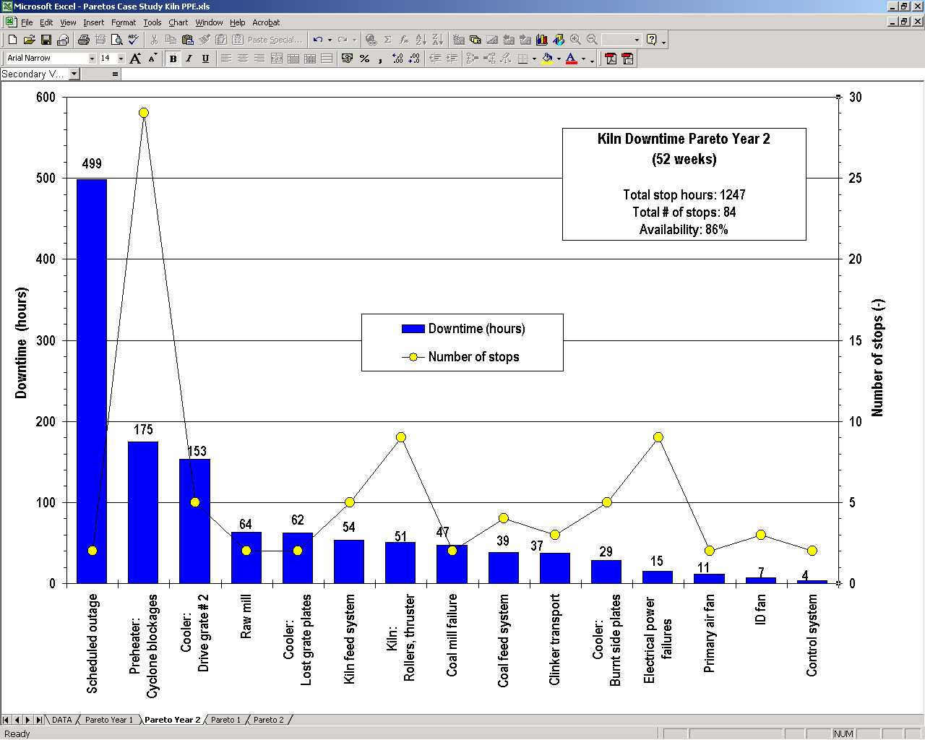

Your Tasks for the Year 2

To meet the growing market demand for cement in the country, an increase in clinker volume is required for the next year. Further the petcoke potential identified by the petcoke initiative (75% petcoke at 6% sulfur) has to be exploited. You as the process performance engineer are in charge of deciding the adequate measures to achieve   
**the targets for the next year:**

* **Clinker production of 825'000 t/a**(6.5% increase compared to current budget)
* **Kiln availability of 90%**
* **Petcoke fraction of 75% in mix**(potential as identified by petcoke initiative)

First you will **analyse the situation** (identify process problems related to equipment) and search for bottlenecks/weak points in the process that are limiting the production.

Calculate and assess the following process parameters and process analysis indicators:  
**Important: Use the actual values measured during the heat balance of year 2**

| **Parameter** | **Unit** | **Value** | **Assessment, problems expected ?** |
| --- | --- | --- | --- |
| Thermal burning zone load of kiln | MW/m2 |  |  |
| Clinker cooler grate area load | t/d m2 |  |  |
| Clinker cooler grate width load | t/d m |  |  |
| Clinker cooling air installed | Nm3/kg cli |  |  |
| Clinker cooling air volume during heat balance | Nm3/kg cli |  |  |
| Which fan has highest deviation to the installed volume and why? | - |  |  |
| Theoretically achievable clinker temperature with the air volume during heat balance *(Use approximation formula, Practical hint: assume 1400°C clinker inlet temperature)* | °C |  |  |
| Specific secondary air volume  *(Primary air in burner: 5'100 Nm3/h Coal load in transport air: 5 kg/Nm3 False air in kiln hood: 0.025 Nm3/kg cli)* | Nm3/kg cli |  | **n.a.** |
| Tertiary air volume (approximated) *(Practical hint: Use stoichiometric combustion air for PC, neglect primary air, false air and air excess)* | Nm3/kg cli |  | **n.a.** |
| Air velocity at the kiln hood  (critical area at cooler roof level) | m/s |  |  |
| Air velocity in tertiary air duct | m/s |  |  |
| False air intake in stage 2  (2nd lowest cyclone), in % of wet gas volume at inlet of stage 2 | % |  |  |
| Required fineness of coal-petcoke mix (compare with actual value) | %R 90 μm |  |  |
| Gas residence time in precalciner *(Hint: calculate with gas volume  at calciner exit, assume no CO2  released from meal before the calciner)* | s |  |  |
| Sulfur volatility in kiln | - |  |  |

As in last year the plant manager asks you to **locate the bottlenecks/weak points** that are now limiting the clinker production volume. Name at least four weak points and indicate the impact on kiln performance. Use information from the heat balance, Pareto, system loads, list of typical operation parameters.

**Production Year 2**

|  |  |  |
| --- | --- | --- |
| **Process Analysis Indicator, Critical Process Parameter** | **Bottleneck,  Weak Point** | **Impact on Process  (e.g. production, heat consumption, cost)** |
|  |  |  |
|  |  |  |
|  |  |  |
|  |  |  |
|  |  |  |

Just like in the previous year you now **propose the relevant improvement measures** that will allow you to reach the targets for the next year. Possible measures could be: change of kiln operation, modification or replacement of equipment, maintenance. Also estimate the expected CAPEX and kiln downtime in case of equipment modifications.

**Year 2: Improvement Measure # 1**

|  |  |
| --- | --- |
| **Description  of measure** |  |
| **Benefit to performance** (volume, cost, thermal/electrical consumption) |  |
| **CAPEX  and kiln downtime** |  |

**Year 2: Improvement Measure # 2**

|  |  |
| --- | --- |
| **Description  of measure** |  |
| **Benefit to performance** (volume, cost, thermal/electrical consumption) |  |
| **CAPEX  and kiln downtime** |  |

**Year 2: Improvement Measure # 3**

|  |  |
| --- | --- |
| **Description  of measure** |  |
| **Benefit to performance** (volume, cost, thermal/electrical consumption) |  |
| **CAPEX  and kiln downtime** |  |

**Year 2: Improvement Measure # 4**

|  |  |
| --- | --- |
| **Description  of measure** |  |
| **Benefit to performance** (volume, cost, thermal/electrical consumption) |  |
| **CAPEX  and kiln downtime** |  |